Science, Technology, and Engineering
Day 14 & 15: Unit Review
Vocabulary
Fill in each blank with the term that best completes the following sentences.
1. Applying science and mathematics to solve real-world problems is called _______________________.
2. The _____________________________ variable is the factor that is changed in order to test the effect of the change.
3. Testing and evaluating a(n) _____________________________ is an important step in the design process.
4. Engineers perform a(n) _____________________________ to compare the possible negative effects of making a decision involving technology with the possible positive effects.
5. A testable idea or explanation that leads to scientific investigations is called a(n) _____________________.
Key Concepts
Read each question below, and circle the best answer.
6. Which statement best describes technology?
A. the tools, machines, materials, and processes that are used for practical purposes
B. the application of science and mathematics to solve problems that meet the needs of society and improve the quality of life
C. the study of the natural world
D. the exploration of the nature of science
7. Which of the following characteristics is part of a good scientific experiment?
A. Results can be reproduced.
B. Results are not reviewed by peers.
C. Results are based on a small sample size.
D. Results are based on an undisclosed process or procedure.
8. Raoul is studying areas of the United States to find the best location for high-rise senior citizen housing.
Major Earthquakes in Northern California
Year | 1906 | 1911 | 1979 | 1980 | 1984 | 1989
Magnitude | 7.8 | 6.5 | 5.7 | 5.8 | 6.2 | 6.9
To help with his decision on the best location, how could Raoul use this table listing the major earthquakes that have occurred in northern California?
A. to develop a list of building materials
B. to perform a life cycle analysis
C. to create a model
D. to perform a risk-benefit analysis
9. The following graph shows how the speed of an object changes over time.
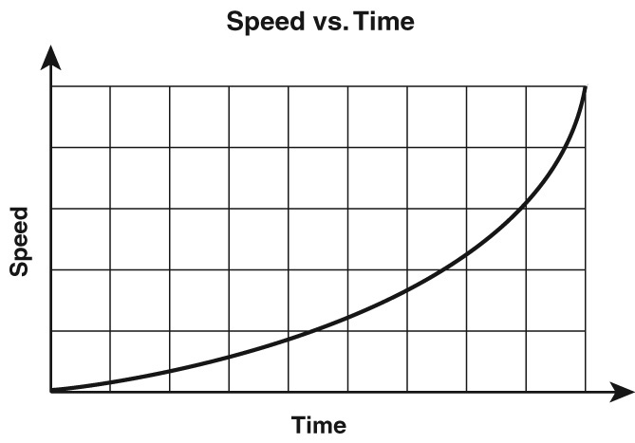
Based on this graph, four different lab groups came to the following conclusions. Which group’s conclusion best describes the result shown in the graph?
A. Group 1: The speed of the object increases as time passes.
B. Group 2: The speed of the object decreases as time passes.
C. Group 3: The speed of the object does not change as time passes.
D. Group 4: The speed of the object decreases then increases as time passes.
10. Which of the following is not a tool used in engineering and technology?
A. computer design program
B. electron microscope
C. suspension bridge
D. power drill
11. Technology used in developing automobiles had some unintended effects.
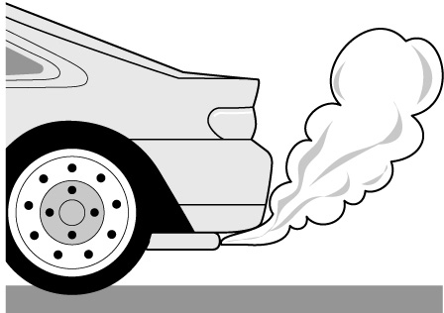
What unintended effect does the illustration show?
A. Automobile technology led to traffic jams in urban areas.
B. Technology used in developing internal combustion engines led to exhaust gases that pollute the environment.
C. Automobile use led to highway accidents.
D. Factories for building automobiles led to jobs and increased economic benefits.
12. Look at the image of a dam.
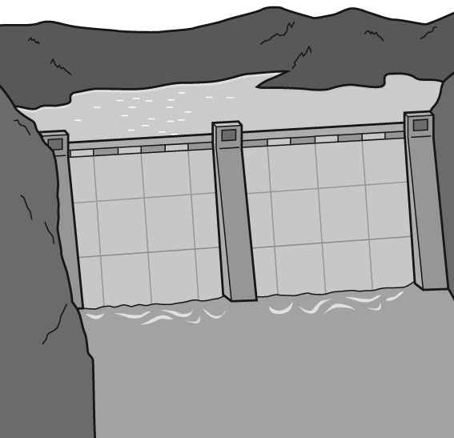
What class of materials are the poured concrete walls of this dam?
A. metals
B. ceramics
C. polymers
D. semiconductors
13. Rosa made this chart when she was studying the properties of various materials.

Material | Time for temperature to increase by  10 degrees (hours)
plastic foam | 5.10
ceramic | 3.20
In what engineering design project would Rosa find this information useful?
A. deciding on material for improved building insulation
B. deciding on new composite materials for athletic shoes
C. deciding on stronger street-paving materials
D. deciding on material for a lightweight, but strong, automobile body
14. The graph shows the results of an experiment done by four groups. Each group used rubber bands of the same size and recorded how far the rubber bands stretched as weight was added to them.
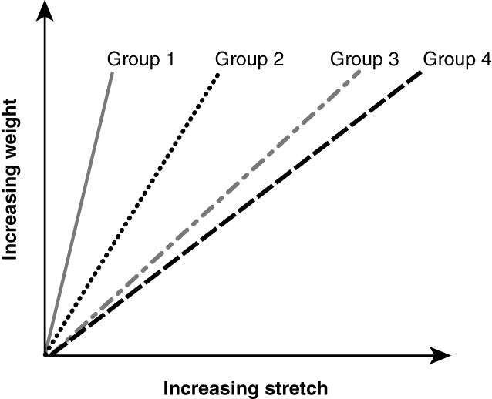
Which of the following best explains why the four groups got different results?
A. They all used metric rulers to measure.
B. There were differences in the rubber bands.
C. They performed the test at different times.
D. They tested the rubber bands with the same weights.
15. Engineers built and used a full-sized prototype, based on the sketch below, to answer questions about the best design for a windmill to generate electricity.
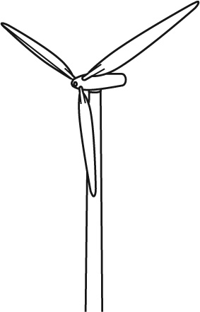
Which of these questions could not be answered by studying the prototype?
A. What would the wind speed and direction be at a given location from month to month?
B. What rotation speed of the blades could produce enough electricity to supply 20 homes?
C. How rapidly would the windmill blades turn at different wind speeds?
D. Would the blades produce high levels of sound when they turned rapidly?
16. Which sequence of events is a logical order for a scientific investigation?
A. experiment → hypothesis → analysis of data → conclusion
B. hypothesis → experiment → conclusion → analysis of data
C. analysis of data → conclusion → experiment → hypothesis
D. hypothesis → experiment → analysis of data → conclusion
Critical Thinking
Answer the following questions in the space provided.
17. Why is it important for experimental procedures and results to be reproducible?

18. This table shows the average life expectancy for males in the United States.
Year of birth | Average life expectancy (y)
1900 | 48
1920 | 56
1940 | 62
1960 | 67
1980 | 70
2000 | 74
What is one inference you can make based on the data in the table?

What is one prediction you can make based on the data in the table?

 ESSENTIAL QUESTIONS
Lessons 1, 2, 4, and 6
Answer the following question in the space provided.
19. Charlia is creating a design for an airplane that can carry 1,500 to 3,000 people. What properties should the material have for the wings and body?

What types of trade-off could there be in using a very expensive, new material?

What improvements could Charlia make to an existing material?

